Candy Floss Instructions
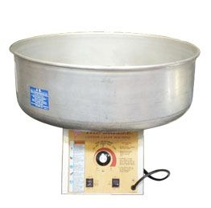
Mix one tablespoon of colour to each 10lbs of ordinary household granulated sugar.
Turn on the Candy Floss Machine.
When it has warmed up, simply fill the head with your sugar mix.

