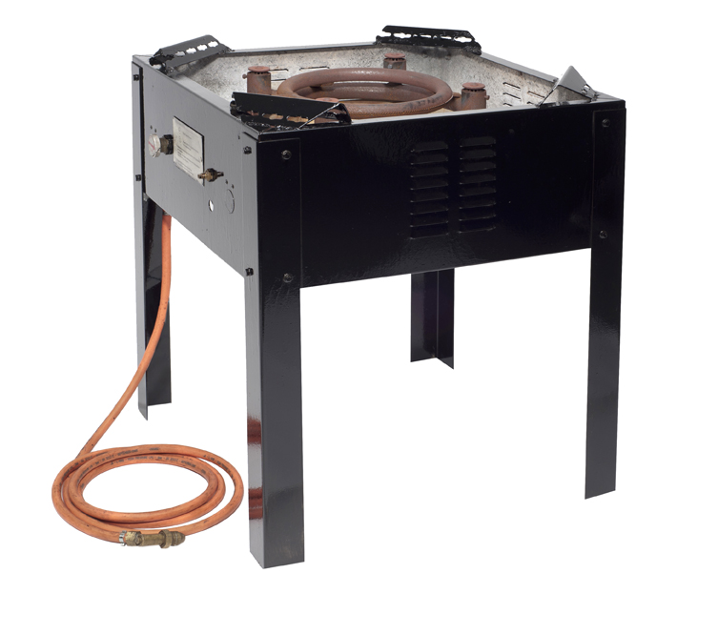
Paella Stand / Burner Instructions

- Connect the gas to the bottle
- Turn on the gas
- Push the button on the regulator to release the gas. Keep holding…
- Light the burner inner-ring by turning the knob to the left (A). Keep turning until all four main burners are lit.
- Release the button on the regulator once all four burners are alight.

A = ON
Z = OFF

